us4R™

An Advanced Ultrasound Research Platform

USER MANUAL

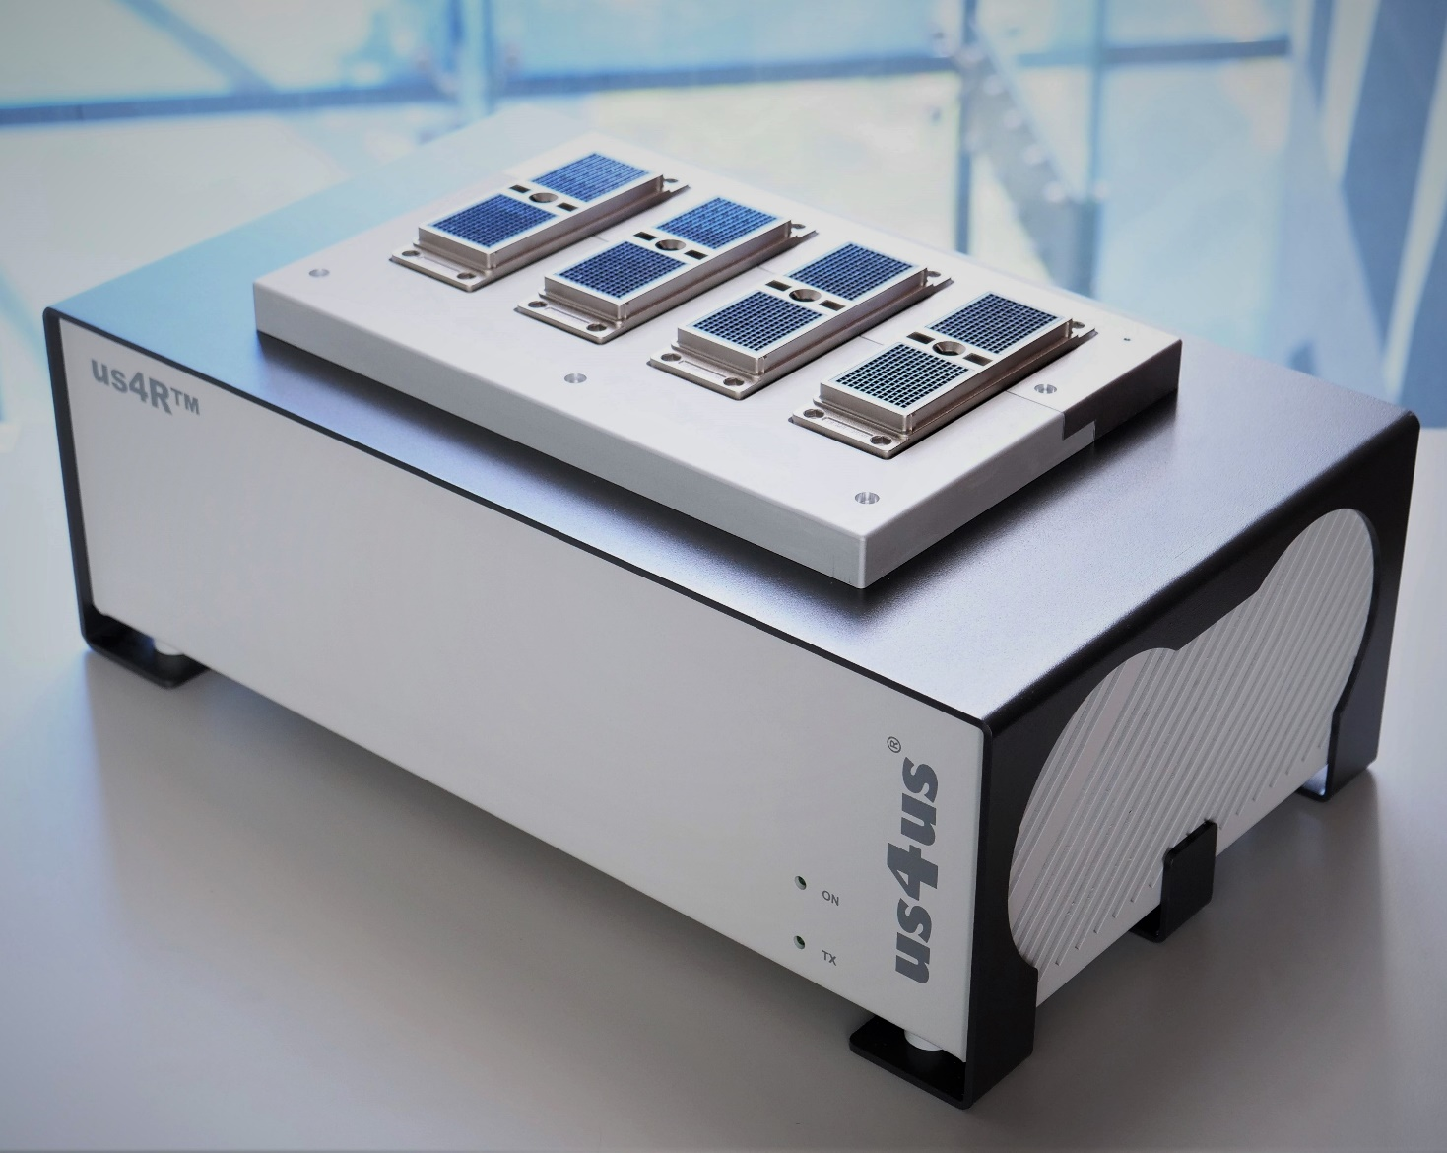

****Version: 2023-v5****

Table of Contents

1 Intended Use 3

2 Interaction of ultrasound 4

2.1 Phenomena accompanying the ultrasound wave 4

3 Unboxing and setting-up the device 5

3.1 Probe Adapters 6

4 Power supply connection 7

5 System setup 8

5.1 Firmware update 8

6 Description and general rules of use 9

6.1 Inputs and outputs 10

6.2 Connecting ultrasound probes 11

6.3 PCIe ports 13

6.3.1 Connecting the PCIe cables 13

6.3.2 Connecting host PC & display 13

6.4 I/O ports 15

6.5 Power switch, cables and ON/OFF button 16

6.6 Setting High-Voltage (HV) supply for the transmitters 16

6.7 First use 17

6.8 Cleaning and maintenance of the device 18

7 Manufacturer guidelines and conditions of use 19

7.1 Conditions of storage and transport 19

7.2 Environmental conditions 19

7.3 Manufacturer EMC recommendations 19

7.4 Other conditions and recommendations 19

8 Technical specification 20

8.1 Technical data 20

8.2 Basic Composition 20

8.3 Detailed specification 20

Legend of symbols 22

9 Current system limitations 23

# Intended Use

The Advanced Ultrasound Research Platform **(us4R™)** is an ultrasonic system intended to be used in an uncontrolled laboratory setting for ultrasound R&D, in particular for real-time implementation of new imaging modalities and algorithms in biomedical and non-destructive testing applications. The system is not a medical device and is not intended for use on humans.

The**us4R™**is a fully programmable ultrasound device built on a novel architecture optimized for streaming acquisition and software processing of raw RF echo signals with the help of GPUs.

|  |  |
| --- | --- |
|  | The device can only be operated by users with a base knowledge of programming and fundamental PC skills. It is essential that users read the full text of the instruction manual before operating the device. |

# Interaction of ultrasound

Ultrasonic waves are mechanical waves, which propagate in a medium (such as liquid, gas, solid and biological tissue). The propagation of ultrasonic waves is related to the transport of energy.

## Phenomena accompanying the ultrasound wave

The intensity of the ultrasound wave (the maximum pressure value) generated by the **us4R™** should not constitute a hazard for test subjects. Nevertheless, it is important to understand how ultrasound interacts with tissues and realize the possible bioeffects caused by mechanical waves.

These bioeffects fall within two categories: mechanical – related to the possibility of cavitation, and thermal – related to the absorption of wave energy by the tissue, which is converted into heat. The amplitude of an ultrasound wave propagating in any absorbing medium, such as a soft tissue, decreases with distance. Damping caused by the absorption and dissipation of the wave leads to energy loss. In the absorption process, part of the energy is converted into heat.

For a detailed examination of ultrasound safety, please consult *The Safe Use of Ultrasound in Medical Diagnosis*, 3rd edition, edited by Gail ter Haar.

|  |  |
| --- | --- |
|  | The user creating a new transmit schema for the us4R™ should always consider the mentioned effects of the ultrasonic wave in a given medium/propagation environment. |

# Unboxing and setting-up the device

The device is delivered to the user pre-assembled and boxed.

The user must connect the components and perform a setup before the first use (see: **5 System setup**)*.* The unboxing of the device should be performed with utmost care.

|  |  |
| --- | --- |
|  | If the device was placed in an environment with climatic conditions that sharply diverge from normal office conditions, it should undergo a process of acclimatization before the first use. This comprises of leaving the device out of the transport packaging for a minimum of 12 hours. |

The packaging should include:

* **us4R™**device (with probe adapter) – 1 pcs.;
* PC system controller – 1 pcs.;
* PCIe cables – 4 or 8 pcs.;
* mains power cable – 1 pcs.;
* (optional) ultrasound probe(s).

In case of any missing items, the Customer is advised to contact the Manufacturer.

Before the first use, it is necessary to ensure that the room has ample space, stable ground and 120/230VAC mains power source with a protective bonding.

The device should be placed to facilitate a safe operation: the power cables must be neither strained nor hanging too loose in a manner that may lead to tripping, wrenching out of cables or otherwise damaging them through breaking or cutting.

Procedures using the **us4R™**should not be performed if the device is in proximity to another working ultrasound device. Ultrasound probes can cause interference, resulting in a falsification of the image.

A proper operation of the device is described in the next chapters of this manual.

|  |  |
| --- | --- |
|  | WARNING: The power cables should be plugged into the 120-230VAC/50Hz/60Hz mains power supply with a protective bonding. |

## Probe Adapters

Several adapters are available for use with the **us4R™** system. Please consult the list of adapters as shown below:

|  |  |  |
| --- | --- | --- |
| Options* | Probes compatibility | Probe Adapters |
| -128RX (4x us4OEM) | up to 128-element probes (linear/phase/convex) | PAU (Ultrasonix Probe Adapter)  VPA (ATL/Philips Probe Adapter)  Custom Probe Adapter (on request) |
| -192RX (6x us4OEM) | up to 192-element probes (linear/phase/convex) | EPA (Esaote Probe Adapter)**  PAU (Ultrasonix Probe Adapter)**  VPA (ATL/Philips Probe Adapter)**  Custom Probe Adapter (on request) |
| -256RX (8x us4OEM) | up to 256-element probes (linear/phase/convex) and up to 1024-element  matrix-array probes | PAU (Ultrasonix Probe Adapter)  VPA (ATL/Philips Probe Adapter)  EPA (Esaote Probe Adapter)  2D MATRIX 2372 Vermon probe  Custom Probe Adapter (on request) |

*\* Switching between 4x, 6x and 8x us4OEM module options can be done by the Manufacturer only.*

*\*\* Not easily interchangeable! If you plan to use probes above 128 elements from various manufacturers   
(e.g. Esaote and Philips probes) please contact us4us to find the best solution for you.*

If you cannot find the adapter that suits your application, it is possible to order a custom probe adapter from the us4us®. Please contact us at [support@us4us.eu](mailto:support@us4us.eu) to discuss the options.

# Power supply connection

|  |  |
| --- | --- |
|  | WARNING: The 120-230VAC power socket used to power the us4R™ must be equipped with a protective earth wire. It is imperative to ensure that the electrical system provides the fire protection required for the class I devices. |

A loss of mains power during operation will result in an immediate shutdown of the device. The **us4R™**will restart once the power is restored.

|  |  |
| --- | --- |
|  | To shut down the us4R™ in case of malfunction, remove the mains power cable from the electrical socket. The electrical sockets should be situated in proximity to the device and be easily accessible. |

# System setup

The **us4R™** should be positioned so that operation is safe — i.e. on a stable, flat surface in a place with no risk of spillage on the device and away from the sources of interference and radiation. The external power supply and power strip should be placed nearby. For more details see section: **6 Description and general rules of use.**

The heat is dissipating by the us4R-3D system during normal work conditions and may slightly increase the temperature of the device surroundings. The ventilation holes on each side of the device must remain uncovered to ensure free flow of air. Covering the ventilation holes risks overheating, shutting down or damaging the **us4R™.** The power and probe cables must not be strained or hang too loosely in a manner that may lead to tripping, mechanical damage, wrenching the cables out of the socket and/or damaging them through breaking or cutting. The audio frequency noise is coming from the fans and sometimes from the HV power supply during transmit during normal work conditions. Please consult the Manufacturer guidelines in section **7 Manufacturer guidelines and conditions of use.**

## Firmware update

NOTE: the **us4R™** system which is shipped to you has the latest firmware already installed.

The firmware update procedure is built into the ARRUS™ SDK package installer. As of today (2021/07/29), only the develop version of the ARRUS package supports the **us4R™**. Follow the instructions available [here](https://us4useu.github.io/arrus-public/releases/current/python/content/installation/index.html#arrus).

Links to the ARRUS™ SDK package documentation are available [here](https://github.com/us4useu/arrus-public).

# Description and general rules of use

|  |  |
| --- | --- |
|  | The device can only be operated by users with a base knowledge of programming and fundamental PC skills. It is essential that users read the full text of the instruction manual before operating the device. |

|  |  |
| --- | --- |
|  | Before first use, you must ensure that the device is complete and in good condition. Any mechanical damage, spillage stains or similar faults require servicing. Under no circumstances can a faulty or damaged network cable be used. |

|  |  |
| --- | --- |
|  | Using the us4R™out of its intended use, or any use that has not been delineated in this manual, will lower the effectiveness of measures put in place to protect the user from danger, and result in a decrease of safety levels. |

The device consists of the **us4R™**device, a host PC computer (picture below), and a set of cables.

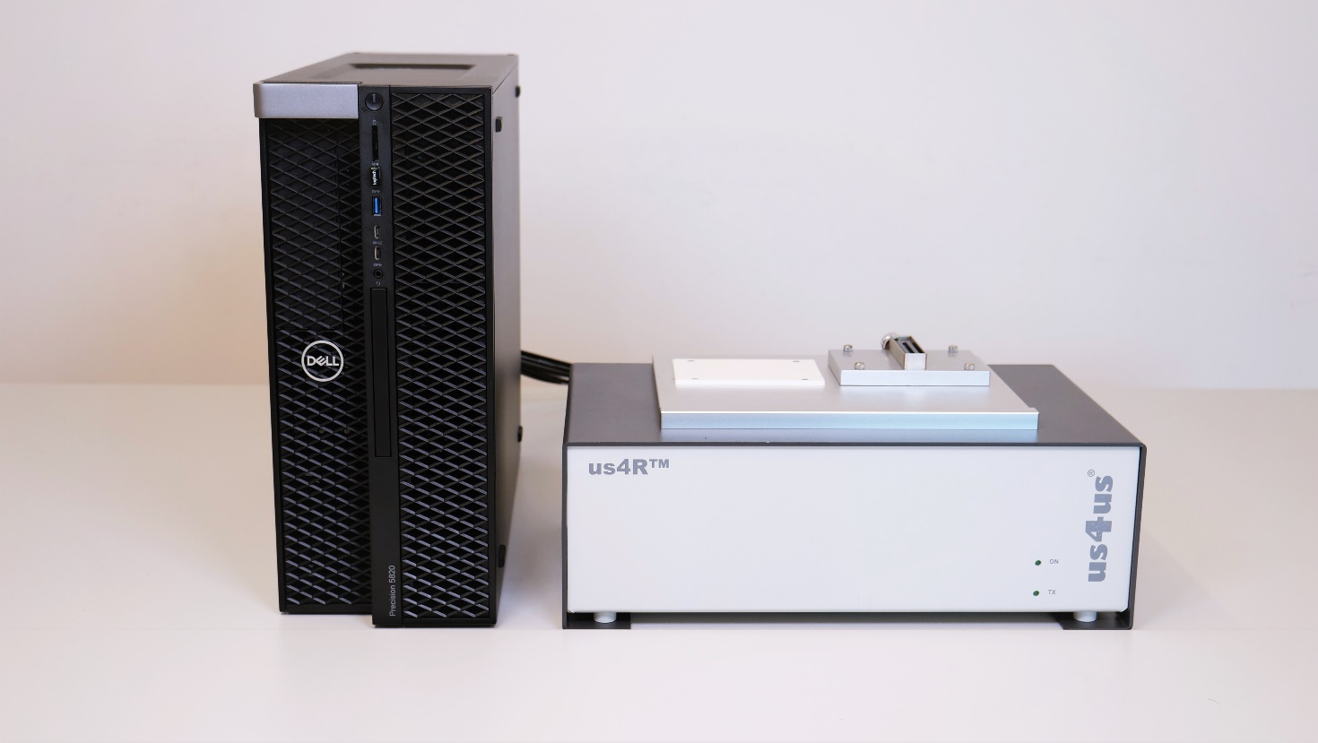

Fig. 6.1 View of a complete system setup.

**As standard, an LCD monitor and ultrasound probes are not provided by the Manufacturer.**

The **us4R™** enables the user to simultaneously connect up to two ultrasound probes (linear/phase/convex). Two connectors (PROBE A and PROBE B) are situated at the top of the device; For matrix-array probe, an dedicated probe adapter is available with 4x DLM6-360 connectors. Only a single probe (linear/phase/convex) probe connector is active at a time. An active probe is used to transmit and receive ultrasound signals that are acquired and processed by the system.

The active connector/probe is chosen in software.

Ultrasound echo signals from the probe are digitized and transmitted via single/dual PCIe gen3 x16 digital interface to the PC, and then further to the GPU cards. Real-time data processing takes place in the CPU/GPUs.

The processed data can be presented graphically on an LCD monitor. The LCD monitor is not supplied with the **us4R™** system and must be provided by the user.

The LCD monitor can be connected to the PC using a dedicated DisplayPort cable.

|  |  |
| --- | --- |
|  | Never unplug the probe from the device during transmission!!!  This can result in damage to the transmit section of the us4R™ device!!! |

|  |  |
| --- | --- |
|  | The device is not equipped with life functions monitoring or alarm systems.  The us4R™ is not designed to monitor life functions! |

## Inputs and outputs

The **us4R™**is equipped with:

* up to 2 or 4 probe connectors (depends on the probe adapter installed),
* 4x or 8x PCIe ports,
* 2x digital inputs,
* 2x digital outputs,
* 1x IEC mains power input.

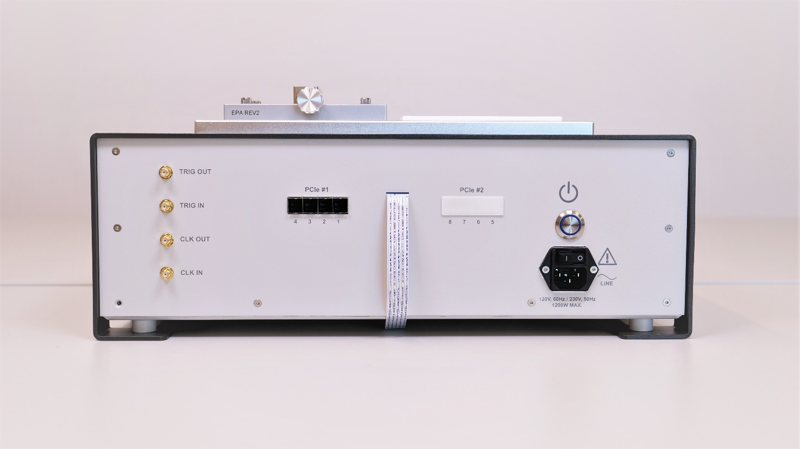

Fig. 6.2 Back-side of the us4R™ device.

**PLEASE NOTE:** External devices should be connected via cables no longer than 3m.

## Connecting ultrasound probes

Ultrasound probes require special care, as they can be easily damaged by an impact. The damaged transducers could have internal element short-circuits or open-circuits, both can cause malfunction or even breakdown of the **us4R™** transmit circuitry. Therefore, it is vital that the probes are handled with extreme care and defective probes are never connected to the system.

Probes should be disconnected from the device during the transport.

The ultrasound probe connectors are situated at the top of the device. 2D probes (linear/phase/convex) connectors are marked as ***PROBE A*** and ***PROBE B*** on the figure below.

Please refer to section ***3.1 Probe Adapters*** for other probe adapters options.

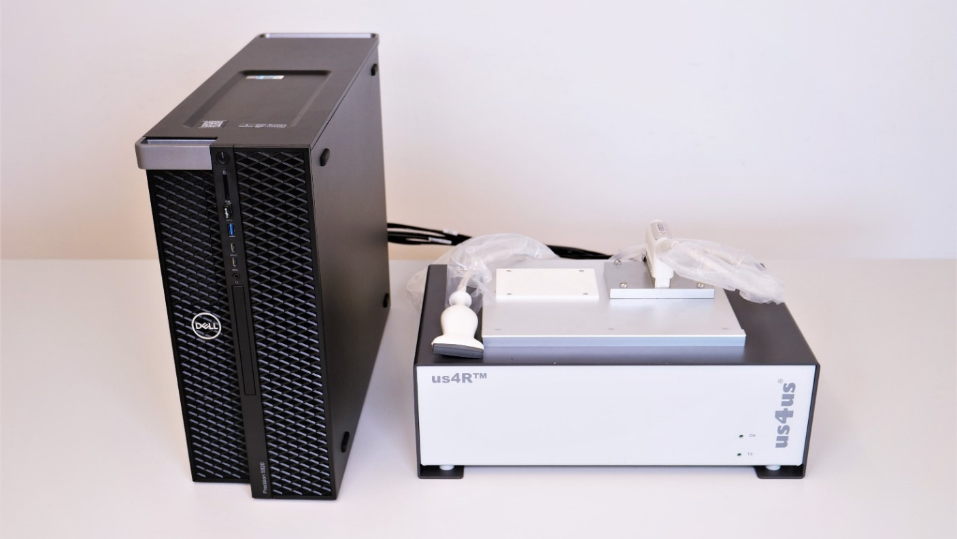

PROBE B

PROBE A

Fig. 6.3 Top-view of the us4R™ with 2D (linear/phase/convex) PROBE A and PROBE B connectors.

A video instruction on how to change the probe adapter for 2D (linear/phase/convex) probes is available on our YouTube channel:

[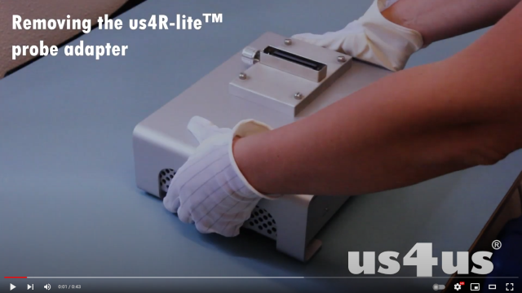](https://www.youtube.com/watch?v=v9DwhbGclBE)  
<https://www.youtube.com/watch?v=v9DwhbGclBE>

**PLEASE NOTE:** Only a probe prepared and configured for use with the **us4R™**can be connected to the device. For assistance, please contact the Manufacturer.

|  |  |
| --- | --- |
|  | Using non-compatible or broken probes can result in damage to the transmission section of the us4R™!!!  Such damages are NOT covered under the warranty!!! |

## PCIe ports

The **us4R™** is equipped with 4 or 8 PCIe ports on the back of the device.

The PCIe ports are intended for connecting the system to an external host PC using dedicated PCIe cables. The **us4R™** is provided with a compatible PC controller that is already equipped with dedicated PCIe host adapter card.

### Connecting the PCIe cables

The delivered PCIe cables are marked #1 to #4 or #8, to help with proper connection of the **us4R™** ports numbered 1…4 or 1…8 to the corresponding ports on the host PC side – also numbered. The proper order of the PCIe cables is essential for device operation and cannot be changed!

When connecting the PCIe cables you should hear/feel “a click” to be sure that the connector is latched properly.

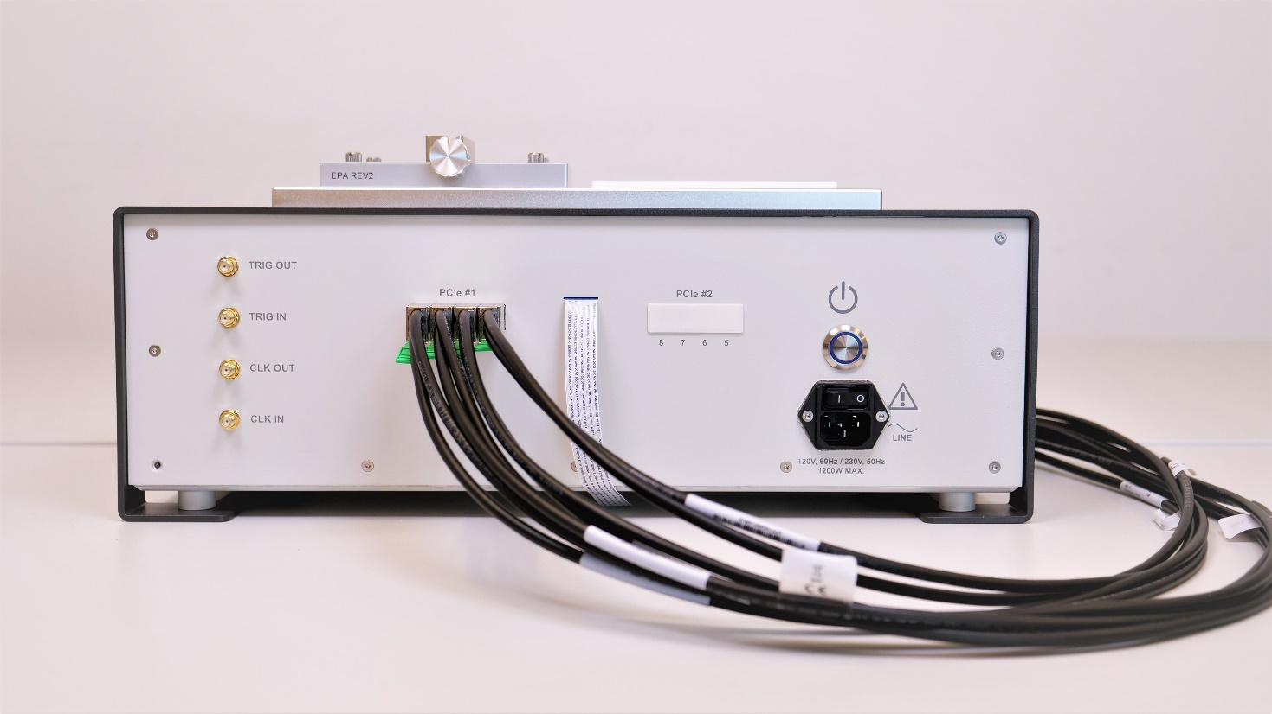

Fig. 6.4 Back panel of the us4R™ showing the PCIe connectors   
and properly connected cabling.

To disconnect the PCIe cables pull the green tab at the bottom of the PCI cable plug (Fig. 6.4).

### Connecting host PC & display

The **us4R™**requires an external host PC with an LCD monitor to function correctly. The only way to connect the **us4R™**device to the PC is through the PCIe cables.

The supplied PC is equipped with one or two PCIe adapter cards – one at the top, one at the bottom of the enclosure (Fig. 6.5).

To disconnect PCIe cables pull the green tab at the bottom of the PCI cable plug (Fig. 6.6).

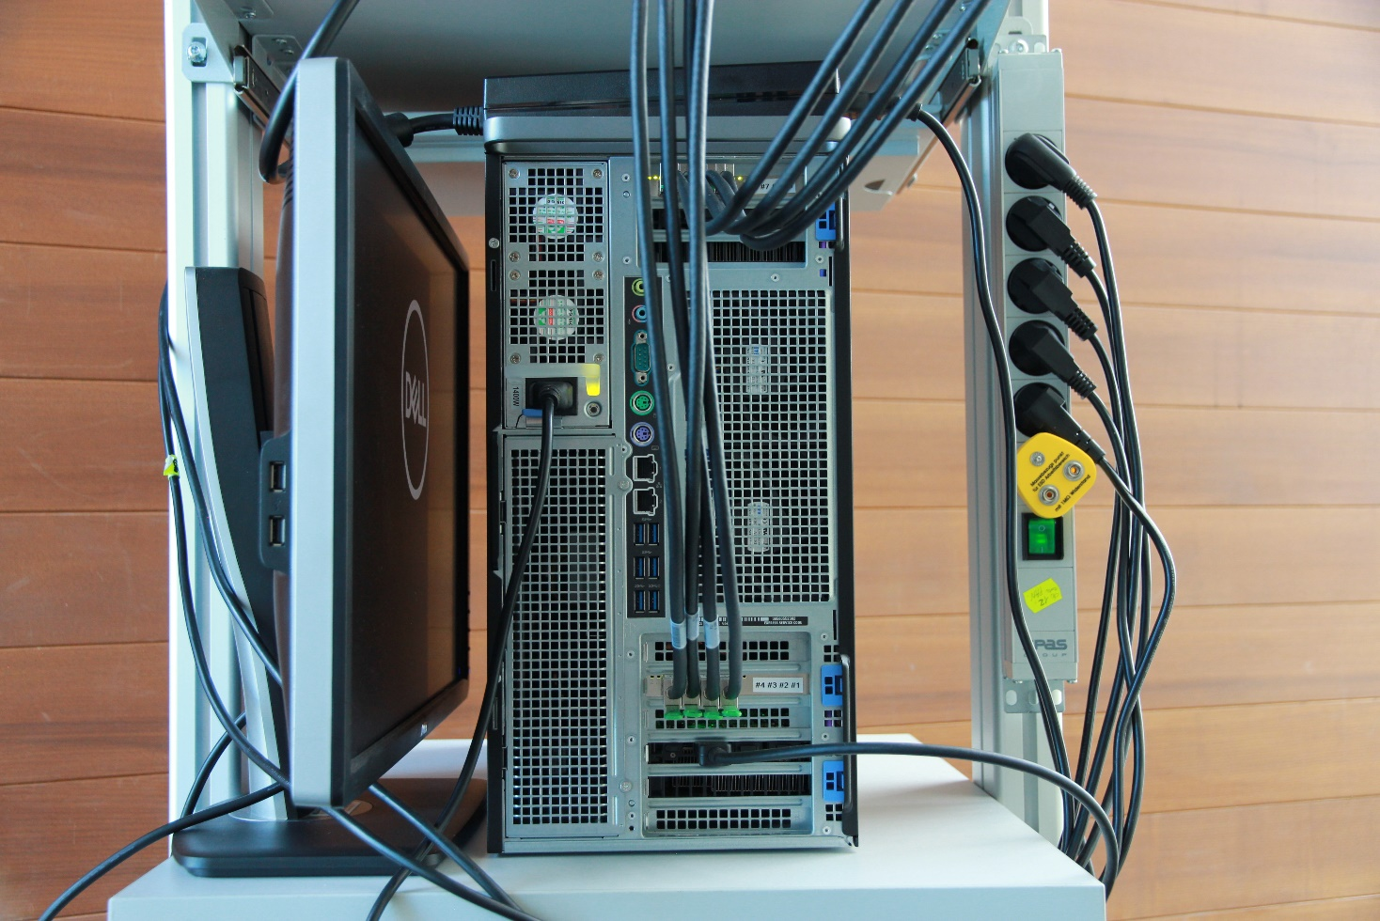

Fig. 6.5 Back-side view of the host PC showing cables connection.

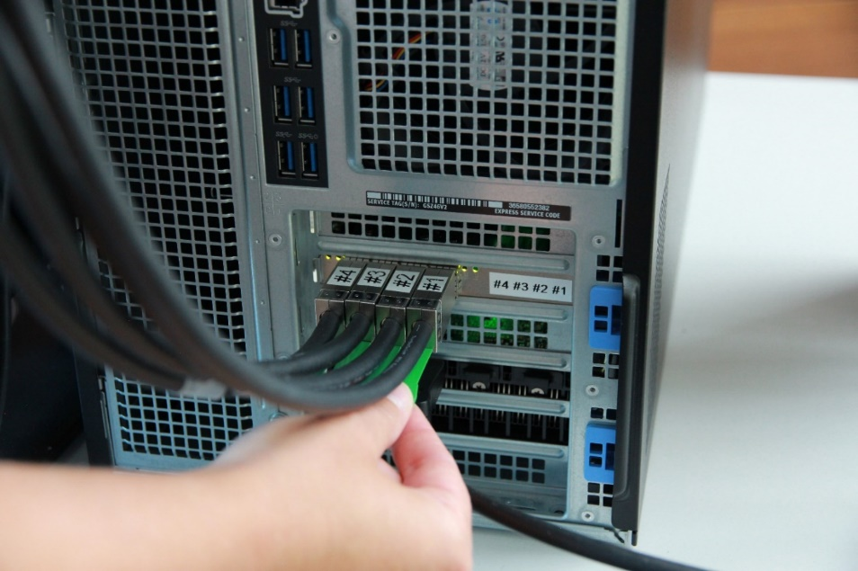

Fig. 6.6 The host PC: the PCIe cables #1..#4 connected to the bottom PCIe interface card.

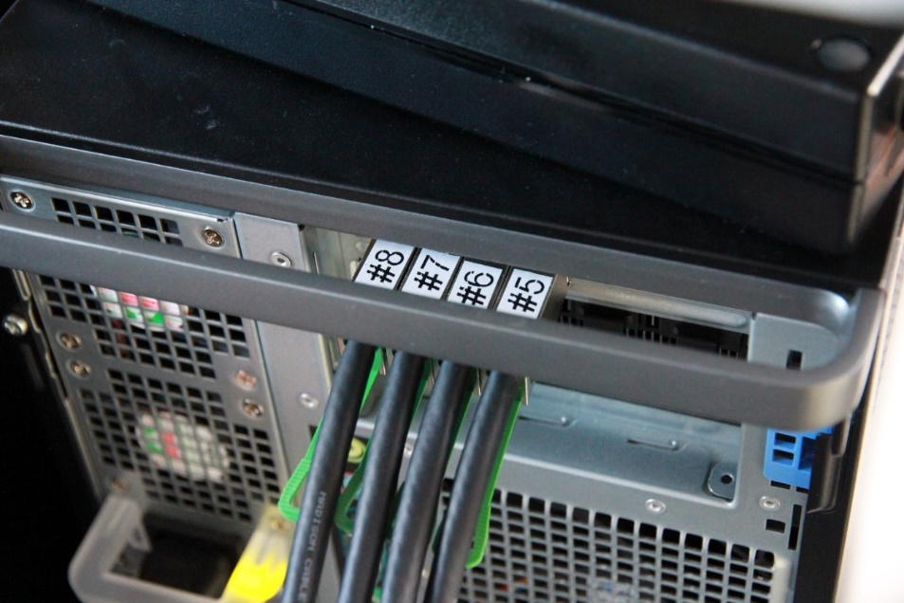

Fig. 6.7 The host PC: the PCIe cables #5..#8 connected to the top PCIe interface card.

## I/O ports

The **us4R™** provides four digital I/O signals in the LVTTL 3.3V standard available on the SMA-type connectors:

1. CLOCK IN – input of an external reference clock signal.
2. TRIG IN – input of an external trigger signal – can be used to synchronize transmit events with other devices/systems.
3. CLOCK OUT – output of an internal reference clock signal.
4. TRIG OUT – output of an internal trigger signal – can be used to synchronize other external devices/systems with the **us4R™**.

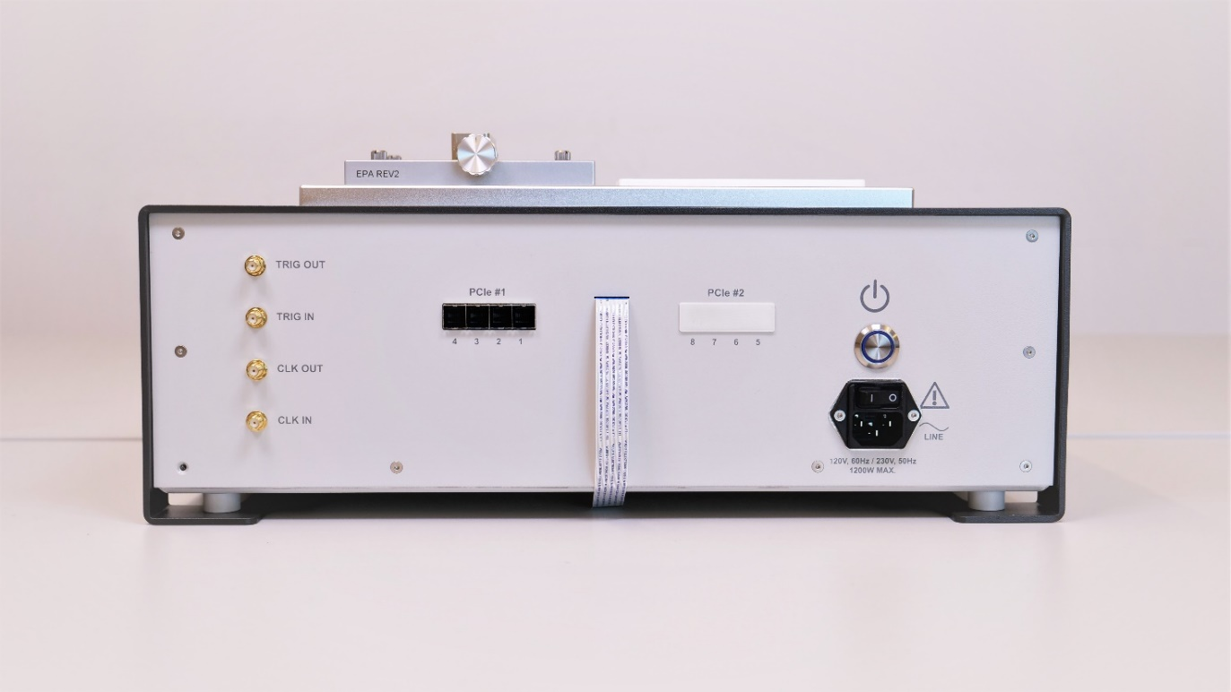

Digital I/Os on the SMA connectors

## Power switch, cables and ON/OFF button

The power cables connection is shown in the picture below.

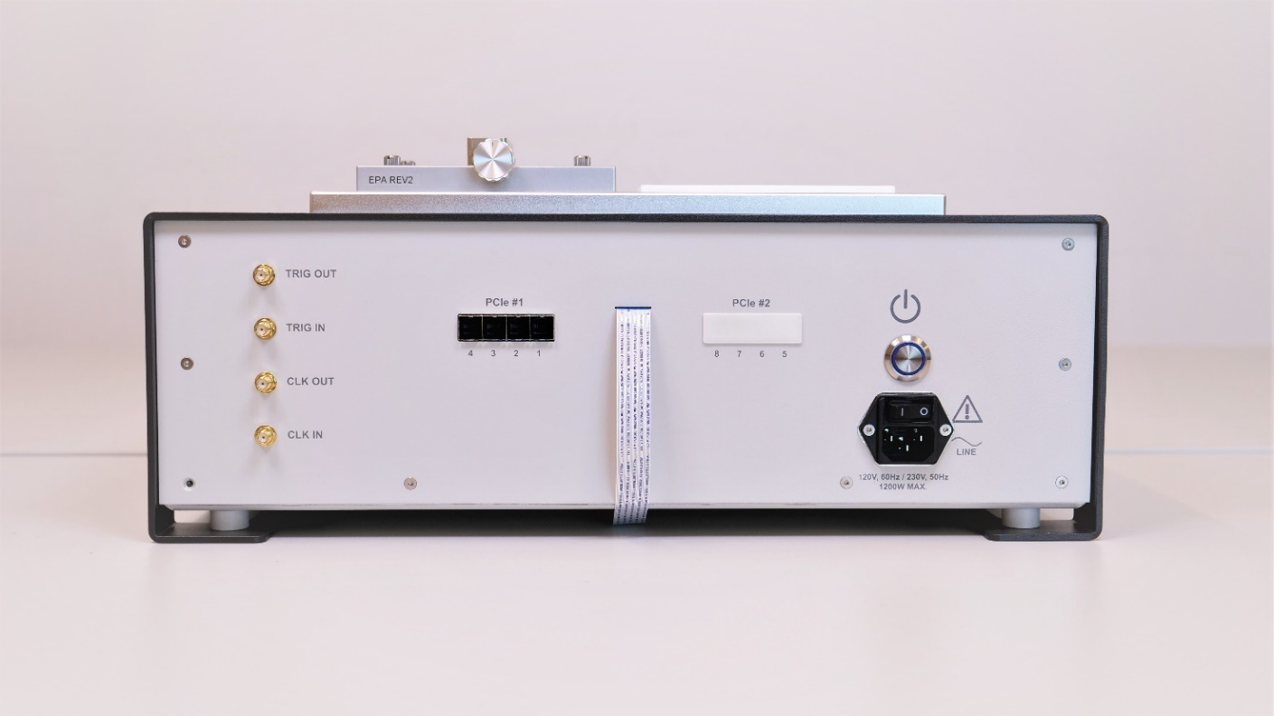

AC mains connector

and Power Switch

ON/OFF button

Fig. 6.8 The us4R™ AC power connector.

## Setting High-Voltage (HV) supply for the transmitters

|  |  |
| --- | --- |
|  | Voltages above 70VDC constitute a life hazard according to EN 61010-1 and great care must be takes when using the power supply at voltages above this level! |

The system TX voltage (so called HV – High Voltage) is one of the most crucial parameters from the system/probe safety point of view. Because the **us4R™** is a research system, it enables the user to change many TX parameters (TX scheme, PRF, TX voltage, pulse length, etc.). **However, some combinations of the TX parameters can be dangerous for the connected ultrasound probe and/or the system itself!** Therefore, the user is fully responsible for verifying a safe set of TX parameters that can be used with the connected probe in a given application. **Application of an excessive TX voltage or power to the probe can (will) result in damage to the system and/or the probe!**

We strongly advise to use the lowest TX voltage possible – as low as reasonably achievable (ALARA rule). Also, please consult us4us® and the probe producer to get advice on the max TX voltage and power that can be delivered to the probe.

## First use

Before first use of the **us4R™**, you must ensure that:

* the device has been set up according to Manufacturer guidelines found in section **5 System setup**,
* proper probe adapter has been installed,
* an external PC and monitor have been connected to the **us4R™**.

Step-by-step instruction:

1. Connect the mains to the **us4R™** and turn the *Power Switch* on***.***
2. Now, turn on the device by clicking the ON/OFF button.
3. Connect the ultrasound probe.
4. Turn on the host PC
   1. Before login check the color of the LEDs on the back of the PC – all 4 or 8 LED indicators (from the top and bottom card) should light up GREEN.

LEDs shine green when PCIe link is OK

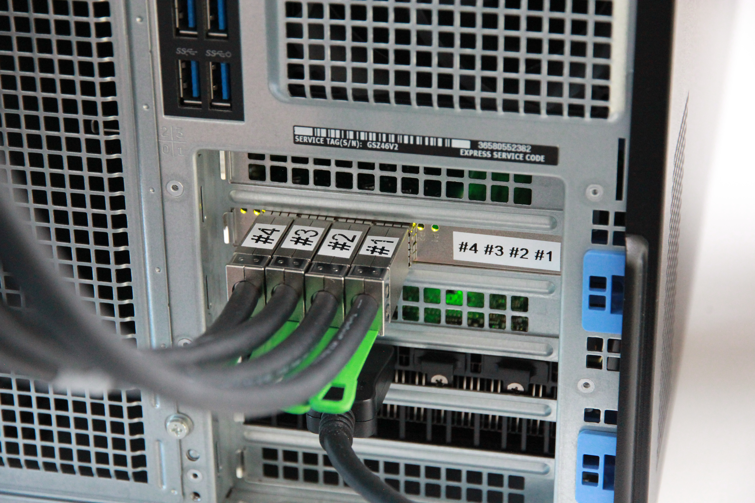

Fig. 6.9 The host PC: the PCIe card interface with four connected PCIe cables   
and the PCIe links LEDs.

IMPORTANT NOTE: If any of the LED indicators light up ORANGE, please reboot the PC. Keep rebooting until all LEDs are green.

1. Log in to the host PC:

user: us4us

password: us4us

1. Make sure to check that the device and its software is starting correctly. If any errors are signaled by the device or messages displayed on screen, proceed according to instructions.
2. Install the ARRUS package according to instructions available [here](https://us4useu.github.io/arrus-public/releases/current/python/content/installation/index.html#arrus) (if it is not already installed).
3. Follow the instruction on how to run “plane wave imaging” example script available [here](https://us4useu.github.io/arrus-public/releases/develop/python/content/examples.html)

(section Examples → Plane Wave Imaging). Please remember to use the configuration file provided.

|  |  |
| --- | --- |
|  | Never unplug the probe from the device during transmission!  This can result in damage to the transmission unit of the us4R™. |

1. Once the test is over, close the image window.
2. The host PC can now be turned off by shutting down the Windows system as normal.
3. Turn off the **us4R™** by pressing the ON/OFF button.
4. After 5 seconds turn off the Power Switch.

## Cleaning and maintenance of the device

The **us4R™**device should be cleaned and disinfected according to standard procedure. However, it is essential to take additional care not to allow any liquids into the device, as this can lead to malfunction and the need for servicing.

The cover of the device can be cleaned with a piece of dry cloth, ensuring no liquids are transported inside.

|  |  |
| --- | --- |
|  | You must ensure that no liquids find their way inside the device!  In case of suspected spillage or moisture inside the device, do not connect the device to a power source or attempt to turn it on, but contact technical service. |

If the device will not be used over the course of two or more days, it should be cleaned and left protected from accidental damage, spillage or contamination at a safe location.

# Manufacturer guidelines and conditions of use

## Conditions of storage and transport

* temperature -1050C,
* relative humidity across the temperature range < 90%,
* atmospheric pressure 5001060 hPa

## Environmental conditions

The **us4R™**is designed for use in the following conditions:

* temperature of environment recommended 16 ÷ 26C, allowable 10 ÷ 40C
* humidity across the range of allowable temperatures 30% ÷ 85%
* atmospheric pressure 5001060 hPa
* environment of II category surge strength (overvoltage)
* 2nd degree contamination environment
* in closed rooms
* up to 2000m above sea level.

## Manufacturer EMC recommendations



The device has limited immunity to electromagnetic interference and thus should be kept as far as possible from its sources (such as mobile phones) during work. If additional interference signals are present and their elimination is not possible, the registered waveforms and digital values should be ignored.

The device has no elements sensitive to a 50Hz/60Hz magnetic field.

## Other conditions and recommendations

It is advised that the device operate at room temperature and at moderate humidity. Any mechanical shocks should be avoided.

|  |  |
| --- | --- |
|  | The Manufacturer recommends that you contact the service and perform a technical inspection (at the Manufacturer or remotely) if you suspect that the device has been mechanically damaged or otherwise diverges from normal appearance. |

The sole service provider for this device is the Manufacturer, us4us Ltd.

The **us4R™** is an electronic device and should be disposed of according to existing regulations.

Production of this equipment required the extraction and use of natural resources. The equipment may contain substances that could be harmful to the environment or human health if improperly handled at the product’s end of life. To avoid release of such substances into the environment and to reduce the use of natural resources, we encourage you to recycle this product in an appropriate system that will ensure that most of the materials are reused or recycled appropriately.

# Technical specification

## Technical data

* Ultrasound frequencies up to 20 MHz;
* Mains power supply 120V/60Hz, 230V/50Hz ±10%
* Power consumption (average) 300W
* Power consumption (max) 600W (expected at max power)
* Dimensions 445 mm × 264 mm × 154* mm

*\*high without probe adapter; total high may slightly differ depending on the Probe Adapter used: +31mm (MAT2372), +37mm (EPA), +50mm (PAU), +38mm (VPA)*

* Weight 10.5 kg

## Basic Composition

* the **us4R™** device (with probe adapter)
* PC system controller with GPU cards
* 4 or 8 PCIe cable
* 2x mains power cable
* (optional) ultrasound probe
* User Manual

## Detailed specification

|  |  |
| --- | --- |
| **Transmit** | |
| Number of channels | 128‑1024 (depends on configuration) |
| Transmit frequency | up to 20MHz |
| TX time delay resolution | up to 5 ns (depends on system clock) |
| Programmable TX voltage | up to 180Vpp (±90V) |
| TX pulsers levels | 3 |
| Per-channel programmable | center frequency, pulse width (pulse duty cycle), pulse length, polarity and delay |
| Pulse repetition frequency | up to 100kHz |
| **Receive** | |
| Number of channels | 128‑256 (depends on configuration) |
| Frequency range | up to 50MHz |
| Programmable anti-aliasing filter  Cutoff | 10, 15, 20, 30, 35, 50 MHz |
| Amplifier gain | * LNA with programmable gain: 24, 18, 12 dB * Voltage-Controlled Attenuator: 40dB * Programmable Gain Amplifier: 24, 30 dB * Total signal chain gain: 54 dB (max) * TGC update rate 1MHz |
| Data sampling | 14-bit @ 65MSPS or 12-bit @ 80MSPS |
| Raw data buffer | up to 128MB per channel |
| **External synchronization** | |
| Output for synchronization | digital, LVTTV 3.3V, 50Ω output impedance |
| Input for synchronization | digital, LVTTV 3.3V, 50Ω input impedance |
| Reference clock output | digital, LVTTV 3.3V, 50Ω output impedance |
| Reference clock input | digital, LVTTV 3.3V, 50Ω input impedance |
| **Ultrasound probes** | |
| Ultrasound probe connectors | 2 connectors of the 2D (linear/phase/convex) probe  or  up to 4 connectors of the 2D array probe |
| Supported probes | * 2D probes (linear/phase/convex): up to 192 el. from Esaote and up to 128 from ATL/Philips/Ultrasonix * Matrix-array 32x32 from Vermon (MAT2372) * probes with up to 1024-elements via a dedicated custom Probe Adapter. |
| **Interface** | |
| Data streaming interface | Single/Dual PCIe gen3 x16 |
| Raw data real-time streaming data  Rate (wire speed) | 1x/2x 16 GB/s |
| Streaming method | PCIe Direct Memory Access; |
| **Software** | |
| Low-level API | C++ (currently RF data acquisition only); Python; Matlab® (not yet supported for us4R) |
| **Power supply** | |
| Mains power | 120-230VAC, 50Hz/60Hz |
| Average power usage (active TX/RX) | 300W |
| External dimensions | 445mm × 264mm × 154amm  *aHigh without probe adapter; total high may slightly differ depending on the Probe Adapter used: +31mm (*MAT2372*), +37mm (EPA), +50mm (PAU), +38mm (VPA)* |
| Weight | 10.5 kg |
| **REQUIRED FOR OPERATION** | |
| **PC host – e.g. Lenovo Thinkstation P620** |  |
| CPU | AMD Ryzen Threadripper PRO |
| Memory – RAM | 32GB |
| Storage | 1TB NVMe PCIe |
| Operating system | Microsoft Windows 10 Pro (64-bit) / Linux Ubuntu 20.04 or newer |
| GPU (optional) | High-performance NVidia GPU with GPU-Direct support |
| PCIe adapter card: | Dolphinics PXH832 |
| **Accessories required for operation** | LCD monitor with DP input |
| USB keyboard and mouse |

Legend of symbols

|  |  |
| --- | --- |
| **SYMBOL** | **DESCRIPTION** |
|  | Radiation/electromagnetic interference |
|  | CAUTION!  Consult the instruction manual before use. |
|  | ON/OFF Switch. |
|  | Keep in a dry place. |
|  | Range of allowable temperatures. |
|  | WEEE – electronic device, should be disposed of according to existing regulations. |
|  | Date of manufacture. |

# Current system limitations

Here is a list current system limitations:

* Standard sampling frequency is 65MSPS. Sampling at 80MSPS requires a change of system firmware.
* The us4R driver for Linux is currently in alpha and may have some bugs. We are working on resolving the most important issues.

The above limitations may be removed in future versions of the system software/firmware.

# Version history

|  |  |  |
| --- | --- | --- |
| ver. / date | Author | Change description |
| 4 / 05 DEC 2021 | BW | Section *5 System setup* updated  Section *7.4 Other conditions and recommendation* extended |
| 5 / 02 MAR 2023 | BW | Section *8.3 Detailed specification* updated  Section *9 Current limitations* updated |